**St. Thomas Craft**

[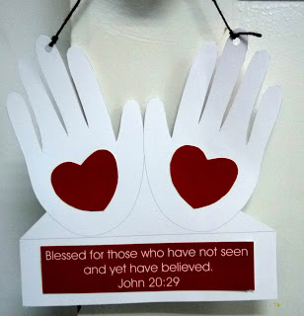](http://1.bp.blogspot.com/-3prlRAUni7Y/T-A8pxWzfoI/AAAAAAAAArQ/VJU2GTgo2JY/s1600/P1130913.JPG)